**Experiment No : 3(a)**

**Name : Mohammad Sohail Shaikh A56**

**Code: Write a Python program that reads month and day and prints the season for that month and day**

def get_season(month, day):

"""

Determines the season based on the month and day.

:param month: Month as an integer (1 to 12)

:param day: Day as an integer (1 to 31)

:return: Name of the season (str)

"""

if (month == 3 and day >= 21) or (4 <= month <= 6 and not (month == 6 and day > 20)):

return "Spring"

elif (month == 6 and day >= 21) or (7 <= month <= 9 and not (month == 9 and day > 22)):

return "Summer"

elif (month == 9 and day >= 23) or (10 <= month <= 12 and not (month == 12 and day > 20)):

return "Autumn (Fall)"

else:

return "Winter"

# Get user input

month = int(input("Enter the month (1-12): "))

day = int(input("Enter the day (1-31): "))

# Determine and print the season

season = get_season(month, day)

print(f"The season on {month}/{day} is: {season}")

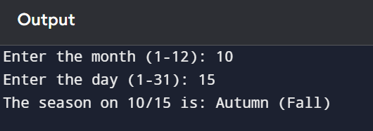

**3(b)**

**Code: write a python program to display even numbers between m and n.(use while loop)**

n1 = int(input("Entet the starting range of loop : "))

n2 = int(input("Entet the ending range of loop : "))

while(n1 < n2):

if(n1 % 2 == 0):

print(n1)

n1 = n1 + 1

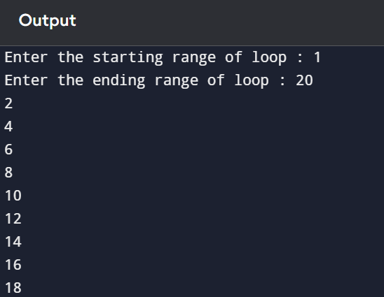

**3(c)**

**Code: write a python program that prints all the numbers from 0 to 6 except 3 and 6. Note : Use ‘continue’ statement.**

for num in range(7): # Loop from 0 to 6

if num == 3 or num == 6:

continue # Skip 3 and 6

print(num)

